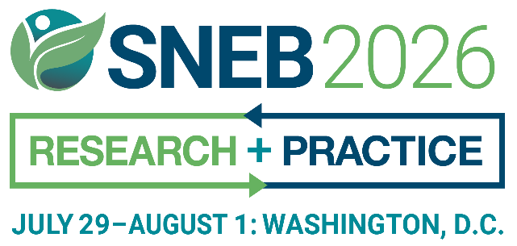
INTRODUCTION
Help us make our upcoming event unforgettable by sharing the excitement! Together, we can inspire, educate, and connect with a diverse audience, sparking curiosity and meaningful conversations. Your voice has the power to shape the future—let’s make it heard!
Use our customizable, premade templates to easily spread the word and save time. Please feel free to use and adapt the content below and help amplify the SNEB International Conference.

SPEAKER TOOLKIT
SOCIAL MEDIA SAMPLE TEXT
Facebook
Attention nutrition educators and professionals: I will be presenting at the #SNEB2026 International Conference. My topic is [add topic/title here].
I would love to see you there!
Learn More: snebconference.org
Instagram
Calling all nutrition educators and professionals! I am thrilled to announce that I will be speaking at the SNEB International Conference organized by the Society for Nutrition Education and Behavior. My presentation will focus on [insert topic/title here].
It would be fantastic to have you join me!
Learn More: snebconference.org
LinkedIn
Attention nutrition educators and professionals: I will be presenting at the Society for Nutrition Education and Behavior’s 2026 International Conference. My topic is [add topic/title here].
I would love to see you there!
Learn More: snebconference.org
-
Sample images:
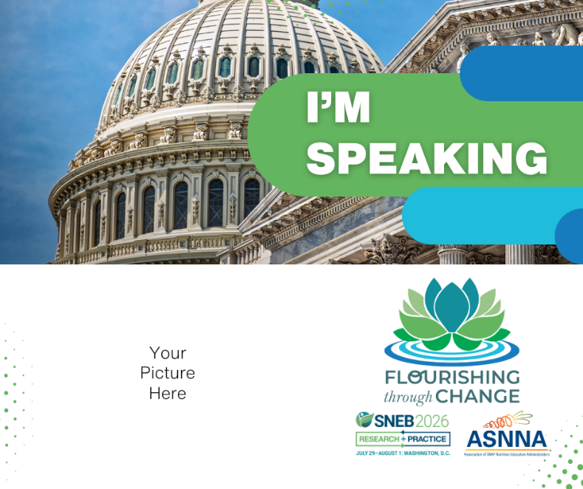
Ex: 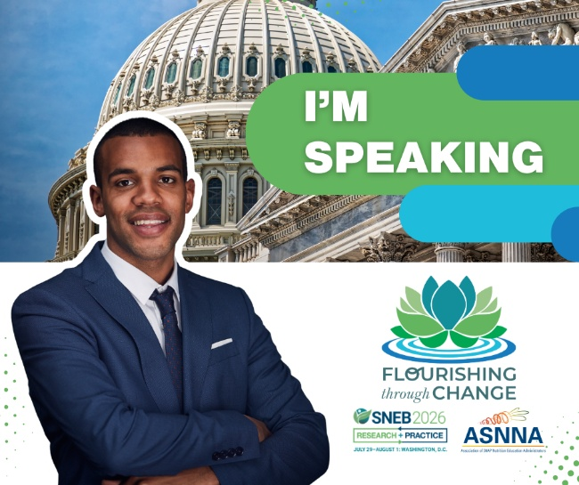
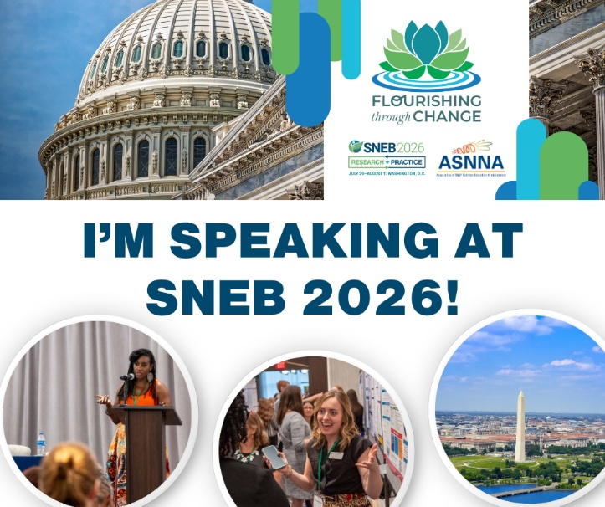

SAMPLE TEXT FOR WEBSITES, SCHOOLS, UNIVERSITIES, OR BUSINESS NEWS OUTLETS
[Your name] will present on [your topic] at the Society for Nutrition Education and Behavior (SNEB) 2026 International Conference hosted in-person in Washington, DC, from July 29 to August 1.
[Add information about yourself, your title and position, and your work. Include how your technique, findings, or other product promote nutrition, healthy communities, or improve healthful behaviors].

SNEB's conference is the only event specifically for nutrition educators. SNEB is an international organization of nutrition education professionals who are dedicated to promoting effective nutrition education and communication to support and improve healthful behaviors, with a vision of healthy communities through nutrition education and advocacy.
For more information, visit snebconference.org

EMAIL SAMPLE
Dear [Colleagues/Students],
For more than 50 years, the Society for Nutrition Education and Behavior (SNEB) has hosted the only event specifically for nutrition educators. I'm proud to announce I'll be presenting [add topic/title/information] as part of the 2026 SNEB International Conference from July 29 - August 1.
Don’t miss a great opportunity in Washington, DC, to learn about new research, creative ideas, and practical techniques applicable in many settings. This year's conference is in-person with livestreaming sessions.
Forward this email to anyone else you know who might be interested.
Learn more at snebconference.org
Thanks, and I hope you can join me!

DEPARTMENTAL ONLINE BULLETIN BOARDS & CALENDARS
The Society for Nutrition Education and Behavior (SNEB) International Conference is the premier event for nutrition education professionals from around the world.
[Insert Your Name] is one of the conference presenters speaking on [Insert Topic]. [Add additional facts about your presentation as appropriate].
The 2026 SNEB conference will be held from July 29 - August 1.
For more information, visit snebconference.org

SAMPLE TEXT FOR LOCAL NEWS OUTLETS
[Open your press release with an anecdote related to your presentation topic. Include compelling information such as new research findings, the importance of nutrition education, and how it directly affects your community. Have you implemented a unique nutrition education program in your school, university, or community? Add it to this press release then tie it in with the conference. Include your title and position].
[Your name] will present on [your topic] at the Society for Nutrition Education and Behavior (SNEB) 2026 International Conference hosted in Washington, DC, from July 29 to August 1.
This is the only event that is specifically for nutrition educators. SNEB is an international organization of nutrition education professionals who are dedicated to promoting effective nutrition education and communication to support and improve healthful behaviors, with a vision of healthy communities through nutrition education and advocacy. For more information, contact SNEB at 800-235-6690 or visit snebconference.org

