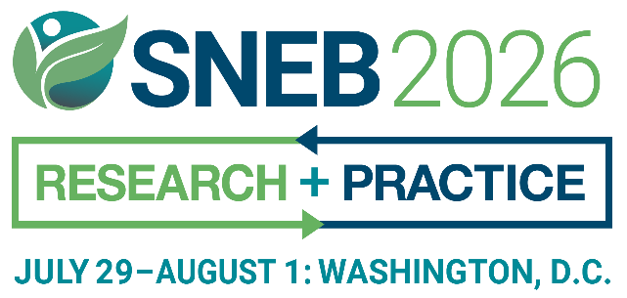
INTRODUCTION
Help us make our upcoming event unforgettable by sharing the excitement! Together, we can inspire, educate, and connect with a diverse audience, sparking curiosity and meaningful conversations. Your voice has the power to shape the future—let’s make it heard!
Use our customizable, premade templates to easily spread the word and save time. Please feel free to use and adapt the content below and help amplify the SNEB International Conference.

EXHIBITOR TOOLKIT
SOCIAL MEDIA- SAMPLE TEXT
Facebook
Attention nutrition educators and professionals: [Your Company Name] will be exhibiting at the SNEB International Conference July 29 - August 1. Visit our booth to learn more about [insert product/service/highlight]. We can’t wait to connect with you!
Learn More: snebconference.org
Instagram
Join us at the Society for Nutrition Education and Behavior’s #SNEB2026 International Conference this July 29 to August 1 in Washington, DC! Visit our booth to learn more about [insert product/service/highlight]. We’d love to see you there!
Learn More: snebconference.org
LinkedIn
Attention nutrition educators and professionals: I will be attending the Society for Nutrition Education and Behavior’s 2026 International Conference from July 29 to August 1. I would love to see you there!
Learn More: snebconference.org

Sample image:
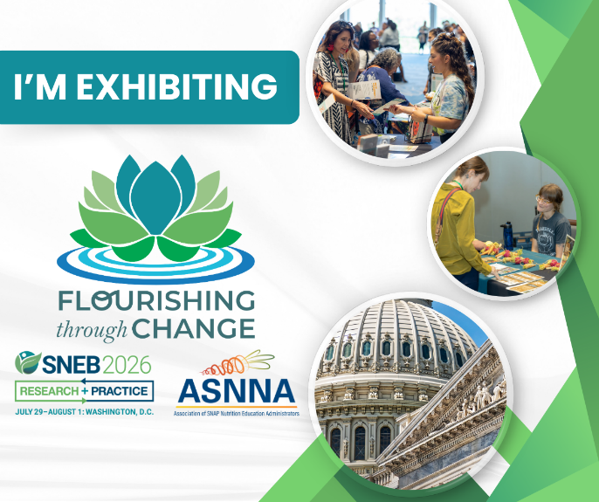

SAMPLE TEXT FOR WEBSITES, SCHOOLS, UNIVERSITIES, OR BUSINESS NEWS OUTLETS
[Your Company Name] will exhibit at the Society for Nutrition Education and Behavior (SNEB) 2026 International Conference in Washington, DC, from July 29 - August 1.
[Add details about your company, your role in the industry, and what attendees can expect from your booth. Mention any exclusive promotions, product demonstrations, or innovations you’re showcasing at the conference.]
SNEB's conference is the only event specifically for nutrition educators. SNEB is an international organization of nutrition education professionals who are dedicated to promoting effective nutrition education and communication to support and improve healthful behaviors, with a vision of healthy communities through nutrition education and advocacy.
For more information, visit snebconference.org
SAMPLE TEXT FOR WEBSITES, SCHOOLS, UNIVERSITIES, OR BUSINESS NEWS OUTLETS
[Your Company Name] will exhibit at the Society for Nutrition Education and Behavior (SNEB) 2026 International Conference hosted in-person in Washington, DC, from July 29 - August 1.
[Add details about your company, your role in the industry, and what attendees can expect from your booth. Mention any exclusive promotions, product demonstrations, or innovations you’re showcasing at the conference.]
SNEB's conference is the only event specifically for nutrition educators. SNEB is an international organization of nutrition education professionals who are dedicated to promoting effective nutrition education and communication to support and improve healthful behaviors, with a vision of healthy communities through nutrition education and advocacy.
For more information, visit snebconference.org

EMAIL SAMPLE
Dear [Colleagues/Clients/Partners],
We’re excited to announce that [Your Company Name] will be exhibiting at the Society for Nutrition Education and Behavior (SNEB) 2026 International Conference, July 29 to August 1 in Washington, DC.
This is a fantastic opportunity to connect with professionals dedicated to advancing nutrition education and behavior. Be sure to stop by our booth to learn more about [insert product/service/highlight].
Feel free to share this email with anyone who might benefit from attending the conference.
For more information, visit snebconference.org
Thanks, and we hope to see you there!

DEPARTMENTAL ONLINE BULLETIN BOARDS & CALENDARS

The Society for Nutrition Education and Behavior (SNEB) International Conference is the premier event for nutrition education professionals from around the world.
[Your Company Name] will be exhibiting at the conference and showcasing [insert product/service/highlight]. [Add additional details about your booth and what attendees can expect from your participation.]
The 2026 SNEB will be held July 29 - August 1, hope to see you there!
For more information, visit snebconference.org

SAMPLE TEXT FOR LOCAL NEWS OUTLETS

[Open your press release with an anecdote related to your company’s involvement in the conference. Highlight the importance of your product/service and how it aligns with the conference theme. Mention any unique contributions or innovations you’re bringing to the event. Include your company’s role in promoting nutrition education and healthy communities.]
[Your Company Name] will exhibit at the Society for Nutrition Education and Behavior (SNEB) 2026 International Conference hosted in Washington, DC,from July 29 to August 1.
This is the only event that is specifically for nutrition educators. SNEB is an international organization of nutrition education professionals who are dedicated to promoting effective nutrition education and communication to support and improve healthful behaviors, with a vision of healthy communities through nutrition education and advocacy.
For more information, contact SNEB at 800-235-6690 or visit snebconference.org

