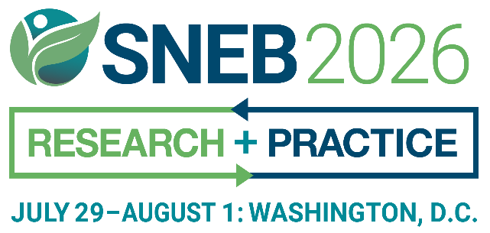
INTRODUCTION
Help us make our upcoming event unforgettable by sharing the excitement! Together, we can inspire, educate, and connect with a diverse audience, sparking curiosity and meaningful conversations. Your voice has the power to shape the future—let’s make it heard!
Use our customizable, premade templates to easily spread the word and save time. Please feel free to use and adapt the content below and help amplify the SNEB International Conference.

ATTENDEE COMMUNICATION TOOLKIT
SOCIAL MEDIA- SAMPLE TEXT & PICTURES
Facebook
Attention nutrition educators and professionals: I will be attending the #SNEB2026 International Conference from July 29 to August 1. I would love to see you there!
Learn More: snebconference.org
Register here: https://snebconference.org/#Registration
Instagram
Calling all nutrition educators and professionals! I am thrilled to announce that I will be attending the #SNEB2026 International Conference, organized by the Society for Nutrition Education and Behavior from July 29 to August 1. It would be fantastic to have you join me!
Learn More: snebconference.org
LinkedIn
Attention nutrition educators and professionals: I will be attending the Society for Nutrition Education and Behavior’s 2026 International Conference from July 29 to August 1. I would love to see you there!
Learn More: snebconference.org
-
Sample Images:
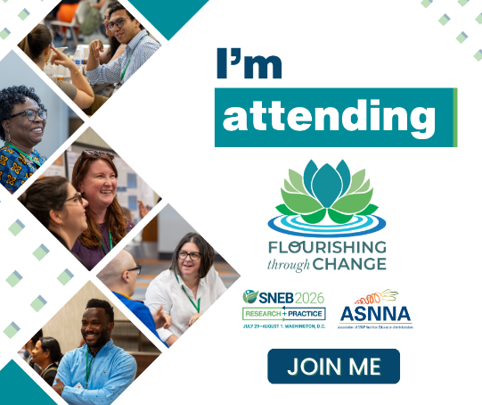
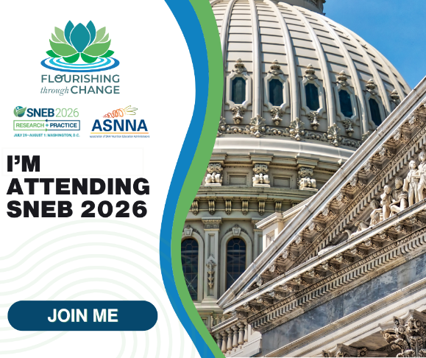

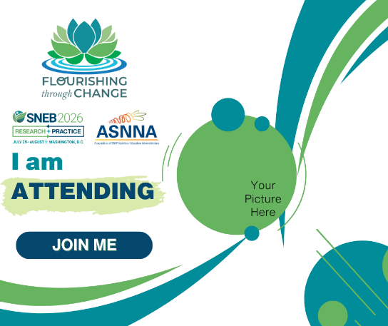
Example:
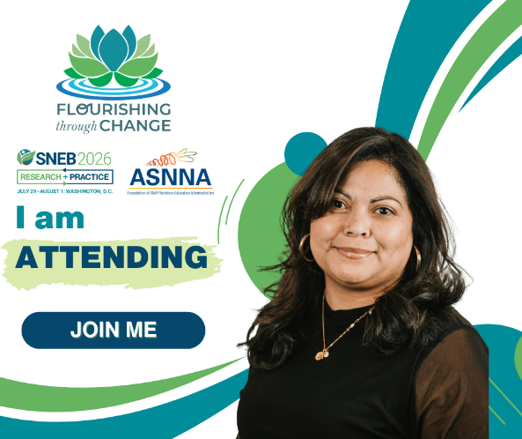

SAMPLE TEXT FOR WEBSITES, SCHOOLS, UNIVERSITIES, OR BUSINESS NEWS OUTLETS
[Your name] will be attending the Society for Nutrition Education and Behavior (SNEB) 2026 International Conference, hosted in-person in Washington, DC from July 29 to August 1.

[Add information about yourself, your title and position, and what you are most interested in at the conference.]
SNEB's conference is the only event specifically for nutrition educators. SNEB is an international organization of nutrition education professionals who are dedicated to promoting effective nutrition education and communication to support and improve healthful behaviors, with a vision of healthy communities through nutrition education and advocacy.
For more information, visit snebconference.org.

EMAIL SAMPLE
Dear [Colleagues/Students],
For more than 50 years, the Society for Nutrition Education and Behavior (SNEB) has hosted the only event specifically for nutrition educators. I'm proud to announce I'll be attending the 2026 SNEB International Conference from July 29 to August 1.
Don’t miss a great opportunity in Washington, DC, to learn about new research, creative ideas, and practical techniques applicable in many settings. This year's conference is in-person with livestreaming sessions.
Forward this email to anyone else you know who might be interested.
Learn More: snebconference.org
Thanks, and I hope you can join me!

DEPARTMENTAL ONLINE BULLETIN BOARDS & CALENDARS
The Society for Nutrition Education and Behavior (SNEB) International Conference is the premier event for nutrition education professionals from around the world.
The atmosphere at SNEB’s conference provides the perfect environment to expand your network and the opportunity to learn about new research, creative ideas, and practical techniques applicable in many settings.
The 2026 SNEB conference will be held from July 29 to August 1.
For more information, visit snebconference.org

SAMPLE TEXT FOR LOCAL NEWS OUTLETS
[Open your press release with an anecdote related to SNEB and the conference topics. Include compelling information such as the importance of nutrition education and how it directly affects your community. Have you implemented a unique nutrition education program in your school, university, or community? Add it to this press release, then tie it in with the conference. Include your title and position.]
The Society for Nutrition Education and Behavior (SNEB) 2026 International Conference will be hosted in Washington, DC, from July 29 to August 1.
This is the only event that is specifically for nutrition educators. SNEB is an international organization of nutrition education professionals who are dedicated to promoting effective nutrition education and communication to support and improve healthful behaviors, with a vision of healthy communities through nutrition education and advocacy. For more information, contact SNEB at 800-235-6690 or visit snebconference.org

